Clientes Module

The Procbel.Apps.module.Clientes, is a module that depends from Ventas.

The main view od clients can be “copied” from Procbel.Apps.Modules.companies:

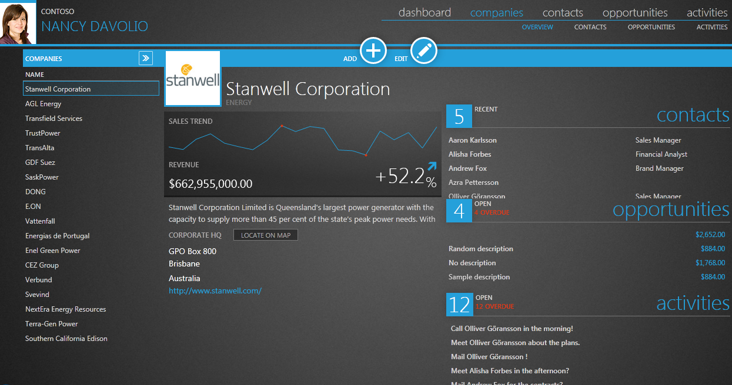

Or on edit mode:

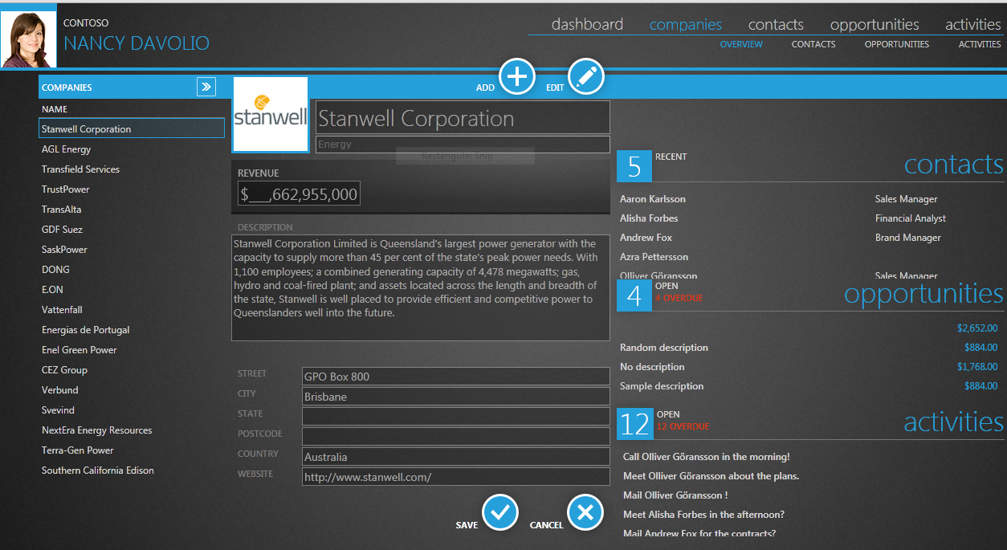

First of all we have to finish Procbel.Apps.Module.Companies.

First every text should have Foreground="{StaticResource text}" so the text can be viewed when the palete I changed from the right panels.

And we have two options for lines: Background="{StaticResource actual}" and Background="{StaticResource budgeted}"

For paths also we have to use: Fill="{StaticResource text}"

All static text should be written into the resources file that are into the infrastructure project.

The entities for the companies module is now made with companies from CRM model this should be change to Companies entities at AppsMainModel.

Also into the edit model now you can not /upload/change/delete logo the table to keep logos is the Image table.

Put a navigation link in the inicio diagram in the Companies ballon near CRM area.

When the module is loaded the Menu/submeu of their orange module Ventas should be loaded.

After did all this then we can create Procbel.Apps.Module.Clientes from the Procbel.Apps.Module.Companies.

Basically is the same but with same changes.

The differences are instead of opportunities, pedidos; instead of opportunities cobros. (this both are not defined so should be only the tittle setted and scafolded.

Also add into the inico diagram ballon a link navigation to this module and view.

The entity for this module is Customers but is linked to the company so the main information is stored into the company entity and other information is in Customer.

To add a new customer first you have to ask if you can use a company from crm as a base or a new one. (free of how to present this but simple).

Then also the edit form is going to be the same but we need “ a second page” to introduce the information referent to the customer entity.